#### http://us.123rf.com/400wm/400/400/etiamos/etiamos1209/etiamos120900017/15120754-kindergarten-sign-with-icons.jpg

As the cold weather approaches, please make sure you are sending warm clothing that your child can dress themselves in as **independently** as possible. Also, we suggest that you send extra mitts, as they may not be dry before your child goes outside again.

Finally, please make sure that all items that you send with your child are **LABELLED**! This is very important in case an item gets lost or misplaced.

**Class Website:** We are continuing to update our website as often as we can! The website features news about what is happening in our room, links you can use at home, and pictures of the many exciting activities we have going on in Poole’s Garden! This is a great tool for you to know what is happening in our room and the children **LOVE** to see their pictures and pictures of their friends! Our website is: <http://poolesgarden2013-2014.weebly.com>



“Play teaches kids how to problem solve, how to make friends, how to express themselves, how to enjoy the world around them, and how to recognize letters and numbers. All of these skills form the foundation of a love of learning.”

"Play lies at the core of innovation and creativity. It provides opportunities for learning in a context in which children are at their most receptive. Play and academic work are not distinct categories for young children, and learning and doing are also inextricably linked for them. "

(Ontario Full Day Early Learning Kindergarten Program, 2010)

Another exciting month comes to a close here in **Poole’s Garden**! We have been enjoying all that Fall has to offer, including using our outdoor classroom, nature walks and pumpkin exploration! We look forward to many new learning experiences as we move into November!

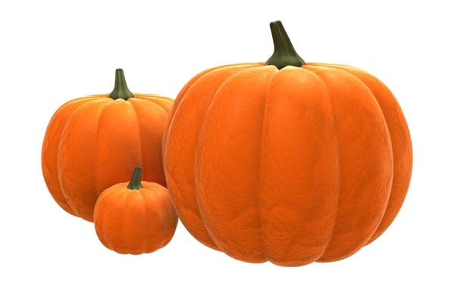

**Student Conferences:** Thank you to everyone who was able to make it out to a conference! In Poole’s Garden, we believe that the connection between what happens at school and what happens at home is **VERY** important to your child’s learning and success! We look forward to continuing to build this relationship with you throughout the year!

**Progress Reports:** For our **SENIOR** Kindergarten students, reports will be sent home with your child on Friday, November 8th. Please note that Junior Kindergartens do **NOT** receive a report this month.

**Class Photos:** We have been receiving questions about class pictures. We did not have a class photo taken on picture day. The class photos are generally taken later in the school year, possibly in February or March.

**Skill Building:** Please continue to practice putting on and off footwear, putting on jackets, and especially zipping up zippers with your child! We have several busy transition times throughout our day and being prepared for these tasks, as well as learning to take personal responsibility for their belongings, are important skills in your child’s kindergarten development.

**November News**

Mrs. Poole & Miss Gardiner

# .

Address Line 1  
Address Line 2  
Address Line 3  
Address Line 4

[Recipient]